C PROGRAMMING ASSIGNMENT
ATM Transaction Simulation
Using Do-While Loop and Switch
Documentation Report
Submitted by | Vishal Prajapati
Roll Number | FDAI044-A
Subject | Programming with C
Faculty In-charge | Dr. Kishor Mahajan
Class | FY-BSC AI
Date | 25 August 2026

Contents
1. Assignment Overview
2. Problem Statement and Objectives
3. Input and Output Specification
4. Algorithm
5. Program Logic and Flowchart
6. Implementation Details
7. Source Code
8. Test Cases and Verified Output
9. Conclusion
10. References

1. Assignment Overview
This project simulates basic ATM transactions through a menu-driven console program. It provides balance enquiry, deposit, withdrawal, and exit operations. A do-while loop keeps the menu active, while switch selects the requested transaction and validation rules protect the account balance from invalid updates.
Item | Description
Assignment | Assignment 2 — ATM Transaction Simulation
Application type | Menu-driven console application
Primary C concepts | do-while loop, switch statement, variables, formatted I/O, relational operators, transaction validation, state update
Execution model | Interactive input, validation, operation, and repeated menu processing
Compiler command | gcc source_file.c

2. Problem Statement and Objectives
- Use a do-while loop so the ATM menu is displayed at least once.
- Use switch to select balance enquiry, deposit, withdrawal, or exit.
- Maintain and update an account balance.
- Reject zero and negative deposit or withdrawal amounts.
- Prevent withdrawals that exceed the available balance.
- Continue until the user explicitly selects option 4.

3. Initial Assumption and Menu
For demonstration, the account begins with an initial balance of Rs. 10,000.00. This value is stored in the balance variable and changes only after successful deposits or withdrawals.
Menu option | Operation | Effect on balance
1 | Balance enquiry | No change; display current balance
2 | Deposit | balance = balance + amount
3 | Withdrawal | balance = balance - amount only if funds are sufficient
4 | Exit | End the program

4. Algorithm
- Set the initial balance to Rs. 10,000.00.
- Display the ATM menu and read the user’s choice.
- Use switch(choice) to execute the selected transaction.
- For balance enquiry, display the current balance.
- For deposit, accept the amount only if it is greater than zero, then add it to the balance.
- For withdrawal, accept the amount only if it is greater than zero and does not exceed the balance. If valid, subtract it from the balance.
- For an invalid menu choice, display an error message.
- Repeat the process while choice is not 4.

5. Program Logic and Flowchart
The program initializes balance and enters a do-while loop. The menu is displayed before the loop condition is tested, which guarantees at least one display. The switch statement routes control to enquiry, deposit, withdrawal, or exit. Deposit and withdrawal amounts must be positive. A withdrawal is processed only when the requested amount does not exceed the current balance; otherwise, the transaction is declined and the balance remains unchanged.
Flowchart symbol key
Rounded rectangle = Start/End; parallelogram = Input/Output; rectangle = Processing; diamond = Decision; circle = Connector.

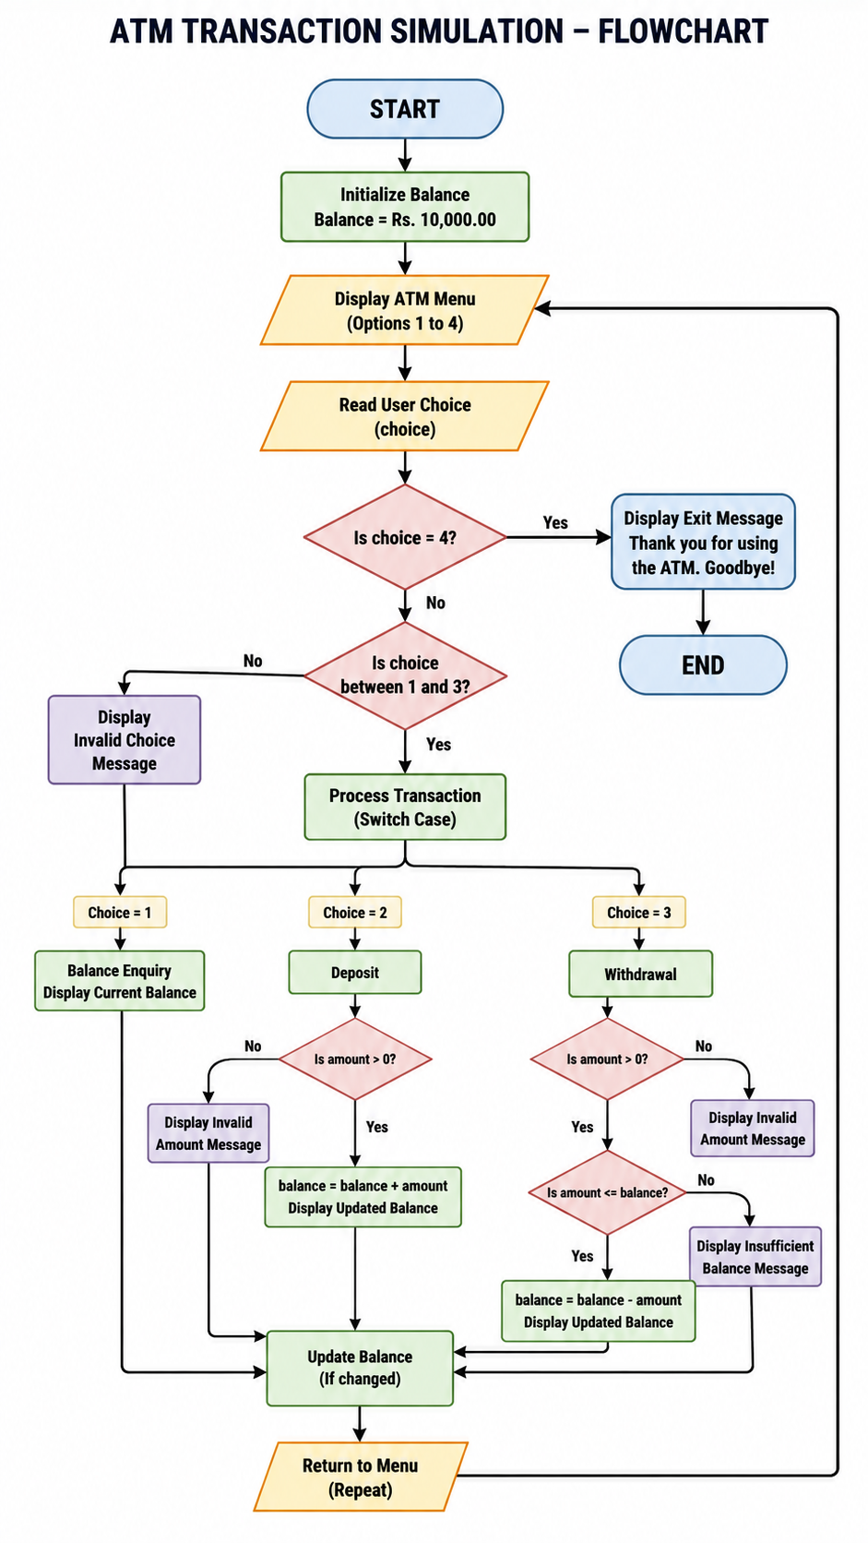
Figure 1. ATM flowchart showing menu repetition, transaction validation, and balance updates.

6. Transaction Validation and Loop Choice
A deposit or withdrawal amount must be greater than zero. Zero and negative values are rejected because they do not represent valid transactions. Before a withdrawal is processed, the program compares amount with balance. If amount is greater than balance, the transaction is declined and the account state remains unchanged.
Why a do-while loop is used
An ATM must display its menu and request at least one transaction before it can determine whether the user wants to exit. The do-while body executes first and tests the condition afterward, directly matching the requirement that the menu continue until Exit is selected.

7. Source Code
1 #include <stdio.h>
2
3 int main(void) {
4 int choice;
5 double balance = 10000.00;
6 double amount;
7
8 do {
9 printf("\n===== ATM Transaction Simulation =====\n");
10 printf("1. Balance Enquiry\n");
11 printf("2. Deposit\n");
12 printf("3. Withdrawal\n");
13 printf("4. Exit\n");
14 printf("Enter your choice: ");
15
16 if (scanf("%d", &choice) != 1) {
17 printf("Invalid input. Please enter a number from 1 to 4.\n");
18 while (getchar() != '\n') {
19 /* Clear invalid input from the keyboard buffer. */
20 }
21 continue;
22 }
23
24 switch (choice) {
25 case 1:
26 printf("Available balance = Rs. %.2f\n", balance);
27 break;
28
29 case 2:
30 printf("Enter deposit amount: Rs. ");
31 if (scanf("%lf", &amount) != 1) {
32 printf("Invalid amount. Please enter a numeric value.\n");
33 while (getchar() != '\n') {
34 /* Clear invalid input from the keyboard buffer. */
35 }
36 } else if (amount <= 0) {
37 printf("Invalid amount. Deposit must be greater than zero.\n");
38 } else {
39 balance += amount;
40 printf("Deposit successful.\n");
41 printf("Updated balance = Rs. %.2f\n", balance);
42 }
43 break;
44
45 case 3:
46 printf("Enter withdrawal amount: Rs. ");
47 if (scanf("%lf", &amount) != 1) {
48 printf("Invalid amount. Please enter a numeric value.\n");
49 while (getchar() != '\n') {
50 /* Clear invalid input from the keyboard buffer. */
51 }
52 } else if (amount <= 0) {
53 printf("Invalid amount. Withdrawal must be greater than zero.\n");
54 } else if (amount > balance) {
55 printf("Transaction declined: Insufficient balance.\n");
56 printf("Available balance = Rs. %.2f\n", balance);
57 } else {
58 balance -= amount;
59 printf("Please collect your cash.\n");
60 printf("Updated balance = Rs. %.2f\n", balance);
61 }
62 break;
63
64 case 4:
65 printf("Thank you for using the ATM. Goodbye!\n");
66 break;
67
68 default:
69 printf("Invalid transaction choice. Please choose a number from 1 to 4.\n");
70 }
71 } while (choice != 4);
72
73 return 0;
74 }

8. Test Cases and Verified Output
The following tests were executed after compilation with GCC. The sequence demonstrates the initial balance, a successful deposit, an excessive withdrawal, a successful withdrawal, invalid amount handling, invalid choice handling, and exit.
Test | Input sequence | Observed / expected output | Purpose
1 | Choice 1 | Rs. 10,000.00 | Initial balance enquiry
2 | Choice 2; Rs. 500 | Balance becomes Rs. 10,500.00 | Successful deposit
3 | Choice 3; Rs. 20,000 | Insufficient balance message | Reject excessive withdrawal
4 | Choice 3; Rs. 1,000 | Balance becomes Rs. 9,500.00 | Successful withdrawal after deposit
5 | Choice 2; Rs. -100 | Invalid amount message | Reject negative deposit
6 | Choice 5 | Invalid transaction choice | Default case

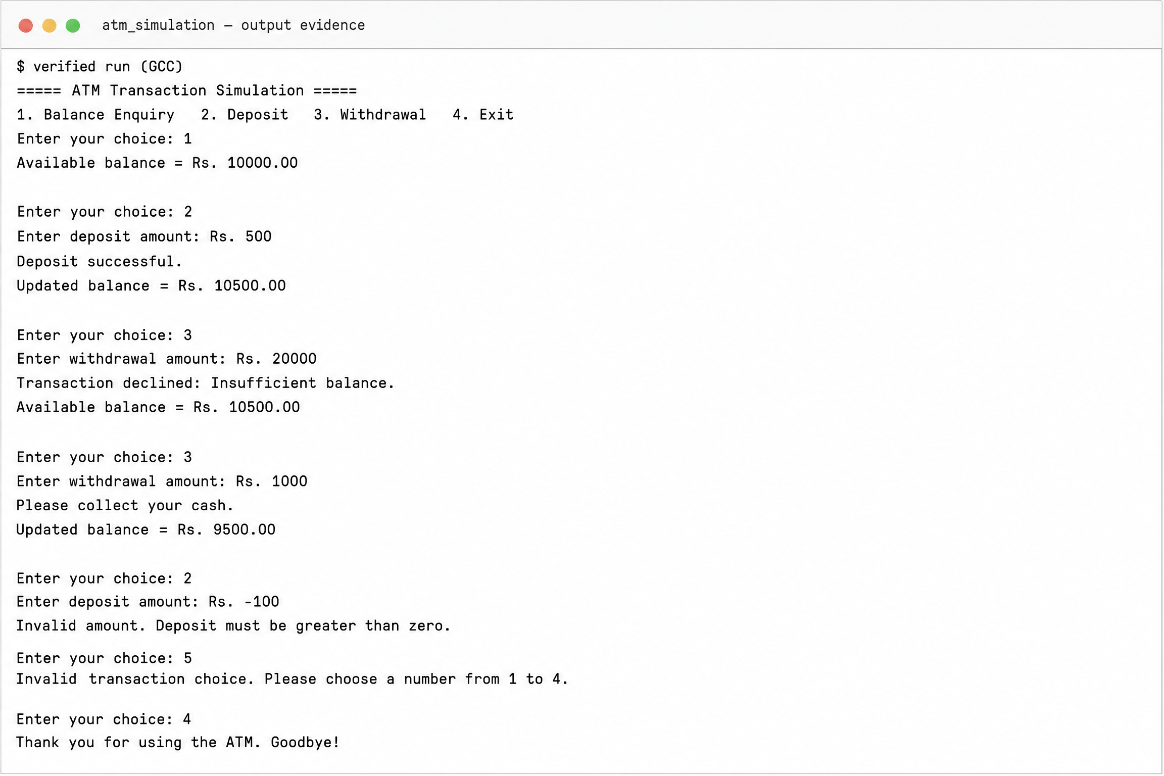
Figure 2. Verified console output showing ATM transactions, validation, and final balances.

9. Conclusion
The ATM simulation uses the required do-while loop and switch statement. It supports balance enquiry, deposits, withdrawals, and exit. Its validation rules prevent invalid amounts and withdrawals that exceed the available balance. The verified console run confirms that successful transactions update the balance while declined or invalid transactions leave it unchanged.

10. References
[1] ISO C standard library reference, cppreference.com: https://en.cppreference.com/w/c
[2] C switch statement reference, cppreference.com: https://en.cppreference.com/w/c/language/switch
[3] C do-while loop reference, cppreference.com: https://en.cppreference.com/w/c/language/do
[4] C mathematical functions reference, cppreference.com: https://en.cppreference.com/w/c/numeric/math

